Briefing paper

Maternity & neonatal care data hub for Scotland

Background
‘The Best Start – A Five Year Forward Plan for Maternity and Neonatal Care in Scotland’, published in January 2017, reports the findings of the Scottish Government’s Review of Maternity and Neonatal Services in Scotland. Recommendation 70 of ‘The Best Start’ is to develop a national maternity and neonatal care data hub and recommendation 67 is “…national level maternity and neonatal dashboards should be developed to facilitate benchmarking and reduce variations in care”.
Engagement in 2018 with the maternity and neonatal services community allowed us to agree what a data hub should include, and to develop the following vision statement for the MatNeo Data Hub:
To ensure the Best Start for mothers and babies in Scotland, a maternity and neonatal data hub should be established to: coordinate collection and verification of all Scottish related neonatal and maternity data; streamline data collection; reduce duplication of data entry; ensure access to relevant data, and support data use to commission, operate and improve services.
The hub was established in 2019 as a collaboration involving five delivery partners (Public Health Scotland, the Scottish Strategic Perinatal Network, Healthcare Improvement Scotland, Scottish Government, and National Records of Scotland), with close links to UK-wide audits and IT system suppliers.
Scottish Government are funding a programme with five work streams:
- Manage a visible Maternity and Neonatal Data Hub for Scotland partnership
- Align Maternity and Neonatal data collection, extraction and data flow
- Establish new all-Scotland maternity data returns
- Routine collection of data on specialist neonatal care.
- Data displays showing maternity and neonatal CORE measures
Further information on each programme work stream is included on the following pages.

Staying informed
We plan to provide regular updates to stakeholders to keep you informed on progress. This will include further short briefings like this, a ‘one-place-to-go’ web presence and quarterly e-mails. To subscribe contact phs.matneodatahub@phs.scot. For further information please contact: Laura Hayes, Project Manager (laura.hayes@phs.scot) or Alastair Philp, Programme Lead (Alastair.Philp2@phs.scot)

COVID-19 & the MatNeo Data Hub
To respond effectively to the COVID-19 pandemic, work since March 2020 has differed from what we originally planned, allowing PHS to meet urgent demands for surveillance data on maternity, neonatal and paediatric care.
As part of our COVID-19 response, Public Health Scotland created a data dashboard showing wider impacts of COVID-19 at https://scotland.shinyapps.io/phs-covid-wider-impact/.This includes data on many aspects of maternity care in Scotland including: Breastfeeding; Stillbirths, neonatal and infant deaths; Antenatal booking appointments (numbers and average gestation; from the new Antenatal Booking Collection data return); terminations of pregnancy (numbers and average gestation); deliveries (gestation, mode (including C-section) and whether induced); term+ singleton births that have a 5 minute Apgar score of <7, and extremely preterm deliveries at sites with a NICU.
We have been receiving weekly submissions of a new antenatal booking collection (ABC) dataset from all Boards since August 2020. This was originally introduced as a temporary measure to allow assessment of the impact of COVID-19 on pregnant women and their babies. However, we have now established the antenatal booking collection as a routine and enduring all-Scotland data return. This allows us to know how many women are pregnant at a point in time and therefore eligible for antenatal screening and immunisations. We have also added mother’s ethnicity to the data items collected (from March 2021). ABC is an early implementation of the antenatal booking component of an Enhanced Maternity Data Set for Scotland (EMaDS).
During 2020 we paused most activities related to EMaDS to focus on establishing the ABC data flow. But we have resumed work now on the Delivery and Baby module. We have also resumed work on the neonatal care dataset (NeoCareIn+). We continued other project work within the Hub programme during 2020 with the resource we had available. This included working to formalise plans for a maternity dashboard core, and cataloguing existing data displays and publications, albeit at a reduced pace.

Components of the MatNeo data hub programme

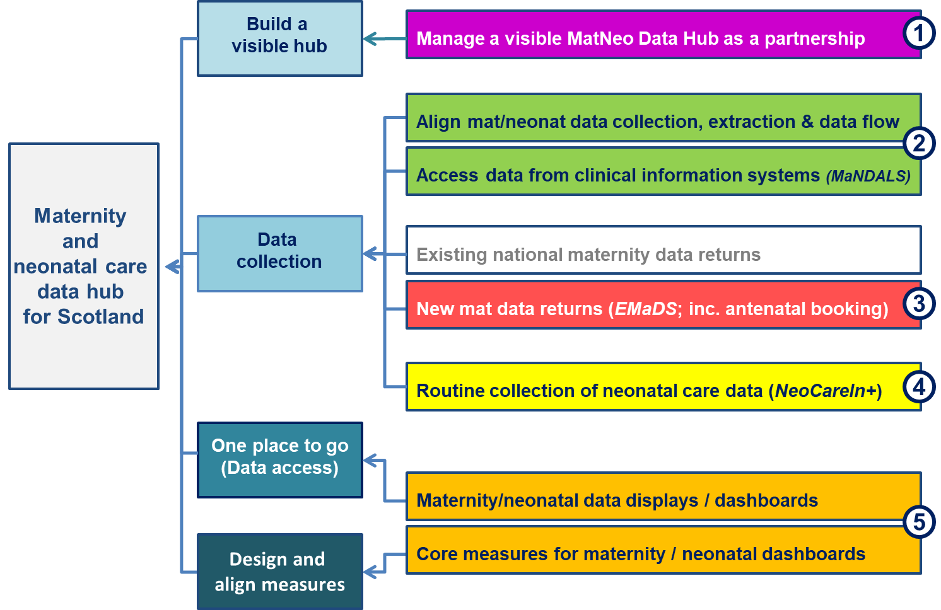

Quick progress update (August 2021) on each work stream
1

Manage a visible Maternity and Neonatal Data Hub for Scotland partnership
As well as managing the inter-dependencies among the projects described below, we have stabilised a partnership involving collaboration among the five delivery partners (Public Health Scotland, the Scottish Strategic Perinatal Network, Healthcare Improvement Scotland, Scottish Government, and National Records of Scotland). We are also developing links to colleagues undertaking similar national work in England (NHS Digital) and Wales, to UK-wide audits and with IT system suppliers.
A MatNeo Data Hub Programme Board, with representatives from each delivery partner, continues to meet quarterly (next meeting planned for Sep 2021) to discuss programme activities and plans.
The MatNeo Data Hub continues to be overseen by the Evidence & Data sub-group of the Best Start Programme Board.
We also circulated a quarterly e-mail update on hub activities to our mailing list at the end of June.
We have prepared a costed proposal for programme activities in 21/22, and subsequent years, and continue to discuss funding for 2021/22, with Scottish Government and within Public Health Scotland.

Align Maternity and Neonatal data collection, extraction and data flow
2
The Maternity and Neonatal Data Access Liaison Group for Scotland (MaNDALS) was established to share updates from multiple parallel conversations involving organisations who require all-Scotland-consistent data for national purposes from clinical information systems (mainly BadgerNet), and to align these conversations. The group met for a fourth time in early June.
We are working with National Services Scotland Digital and Security (DaS) colleagues, with colleagues in NHS Boards, and with Clevermed - who provide the BadgerNet systems - to bring nationally-consistent maternity and neonatal data from clinical systems on to the Seer data holding and analysis platform that DaS have built.
We are negotiating with Clevermed, who provide the BadgerNet systems, to establish a formal service agreement to allow routine data provision.

Establish new all-Scotland maternity data returns (Enhanced Maternity Dataset for Scotland - EMaDS)
3
Throughout 2019 we reviewed the national maternity data return (SMR02) and the national baby data return (SBR), with a view to developing enhanced future maternity and baby data returns that align to current service delivery, and provide more consistent data on maternity care, births and babies.
With the onset of the COVID-19 pandemic we refocussed our Enhanced Maternity Dataset for Scotland (EMaDS) work to capture close-to-real-time data on aspects of antenatal booking. We were already proposing to separate the collection of antenatal booking data from collection of data on delivery (and other ends-of-pregnancy). We decided to dramatically accelerate that, and developed an Antenatal Booking Collection (ABC) data return (as an early implementation of a module of EMaDS).
We have established weekly reporting for antenatal booking data, and have received historic data back to April 2019, so we can report on all women pregnant in March 20 (and thereafter). Numbers of women booking for antenatal care, and average gestation at booking, are published in the pregnancy section of the wider impacts dashboard (https://scotland.shinyapps.io/phs-covid-wider-impact/). This is updated monthly.
The Antenatal Booking Collection data is also being used by the COVID-19 in Pregnancy in Scotland (COPS) Study to identify a cohort of pregnant women. COPS aims to find out how COVID-19 infection during pregnancy affects mothers and babies.
Now we have established an enduring data flow, we are developing proposals to add additional data items to the antenatal booking return, and to make the transfer and holding of the data more automated.
We have also resumed working on other aspects of the EMaDS dataset. We considered how we segment EMADS in to modules. After input from our Programme Board we have decided to focus initially on booking and delivery episodes (including details of baby’s health). We have started development work on both of these. We are also doing some limited scoping work on data regarding early pregnancy and fetal scans.
4

Routine collection of data on specialist neonatal care (NeoCareIn+)
We are working to establish routine collection of a new national (all-Scotland) minimum dataset on specialist neonatal care. In November 2019 we received a one-off extract of data from BadgerNet Neonatal and we analysed this to see what we could learn, and what changes we might need to make to the draft dataset we developed in 2018/19.
We have now finalised a dataset for routine submission. We are discussing with Clevermed (and NHS Boards) how we can have this dataset routinely available, how data will be stored (in the Seer platform mentioned earlier) and planning how data should be presented. We will be writing to Caldicott Guardians shortly with details of the secure data transfer method(s) we plan to use.
Discussions are ongoing with the National Neonatal Network on how best to support their needs.
5

Data displays showing maternity and neonatal CORE measures
We have continued developing CORE maternity measures for incorporation into maternity dashboards. This supports Commitment 67 in Best Start: “National level maternity and neonatal dashboards should be developed to facilitate benchmarking and reduce variations in care”. Such measures, using all-Scotland-comparable data, will support individual services and regional collaborations to learn from each other’s experience.
We previously developed a dashboard demonstrator, which is still available at https://readymag.com/PHIDigital/MatNeoDemonstrator/. This provides links to existing data displays and to the list of CORE maternity measures (https://readymag.com/PHIDigital/MatNeoDemonstrator/matcore/).
To extend this, we have developed a “Topics Index”. This catalogues individual maternity and neonatal measures already available, including those on the wider impacts dashboard, Discovery, NMPA, NNAP and PHS websites. During May and June 2021, we presented a ‘beta’ (preview) version of the Topics Index to key stakeholder groups (including MCQIC leads, Heads of Midwifery, Clinical Directors of Obstetrics, SG policy leads, Digital Midwives and the Neonatal Network). We launched the Topics Index at the end of July 2021.
Having agreed the most appropriate data display platform(s) for maternity CORE measures with our Programme Board, we are developing additional displays to add to the existing public-access wider impacts dashboard (and its successor post-COVID) and to the access-controlled Discovery dashboard.
Members of the programme team are continuing to work with a National Neonatal Network Data Group, to develop a companion neonatal dashboard CORE.

See http://www.gov.scot/Topics/People/Young-People/child-maternal-health/neonatal-maternity-review
See https://docs.google.com/spreadsheets/d/1iAcRF8gc1-k7341JygofiSUmsvmKJ_OxUPyE07XVTPU/edit#gid=277533606

