Appendices:

Appendix 1: Loan agreement (compulsory)
Appendix 2: Home blood pressure diary (optional)
Appendix 3: An overview of home blood pressure monitoring
Appendix 4: How to interpret home monitoring (advice for health care professionals)
Appendix 5: Sample GP/Primary MW letter
Appendix 6: Inclusion, Exclusion and Eligibility Criteria
Appendix 7: Clinical Pathway
Appendix 8: Consent to contact form for the evaluation
Appendix 9: Teach Back Questions

APPENDIX 1: Loan agreement template for hospitals

Loan and Data collection agreement for blood pressure monitor

Blood pressure monitor asset number: .............................................................
(Essential for tracking if device malfunctions)

Cuff size:
Name:
Identifier number:
Address:

Declaration: (please initial all boxes)

I accept responsibility for the above equipment and understand I have been asked to monitor my blood pressure through pregnancy and (if postnatally) after my baby is born.

I understand how use the equipment and how to read and interpret my blood pressure readings, using the guidance provided.

I agree to seek advice from the hypertension clinic if my blood pressure reading is out with the levels set within the guidance provided.

I will return the blood pressure monitor as requested.

If the blood pressure monitor stops working or becomes damaged, lost or stolen, I understand that I must report this to the Maternity Unit on the below number and that I am not responsible for the cost of replacement or repair.

I give permission for my clinical data to be used to evaluate the home blood pressure monitoring service.

Name

Hospital number

Date of birth

Signature of agreement to conditions (dated):

Staff name:

Staff signature (dated):

Maternity team contact:
Telephone:

Please copy and give one copy to the woman, place one in notes (if paper based, or document in electronic record) and retain one copy in the Service folder. This should be available in the event of a safety recall.

Appendix 2: HOME BLOOD PRESSURE AND URINE TESTING DIARY
(for women where results reporting is not digital or where women prefer to also keep a paper diary)

Name:
Identifier number:
Address:

Patient

Target blood pressure: .........../ .............

Contact your maternity unit immediately if: …………... / ……………. (or above)

Arm used: Left Right

Please monitor and record your blood pressure at home as you have been instructed. On each occasion take a minimum of 2 readings at least one minute apart. Please record the second of these readings. Sit on a chair with your back supported and both feet on the ground. Sit quietly for 5 minutes before beginning to check your blood pressure.

Use the table below to record your blood pressure and urine readings. The numbers you write down should be the same as appear on your screen or urine chart. Do not round the numbers up or down.

DATE | TIME | SYSTOLIC BP (top number) | DIASTOLIC BP  (Middle number) | Urine: Protein Reading | Urine: Glucose  Reading | NOTES (eg. Medication changes)
Eg. 06/03/20 | 0945 | 134 | 83 |  |  | No medication

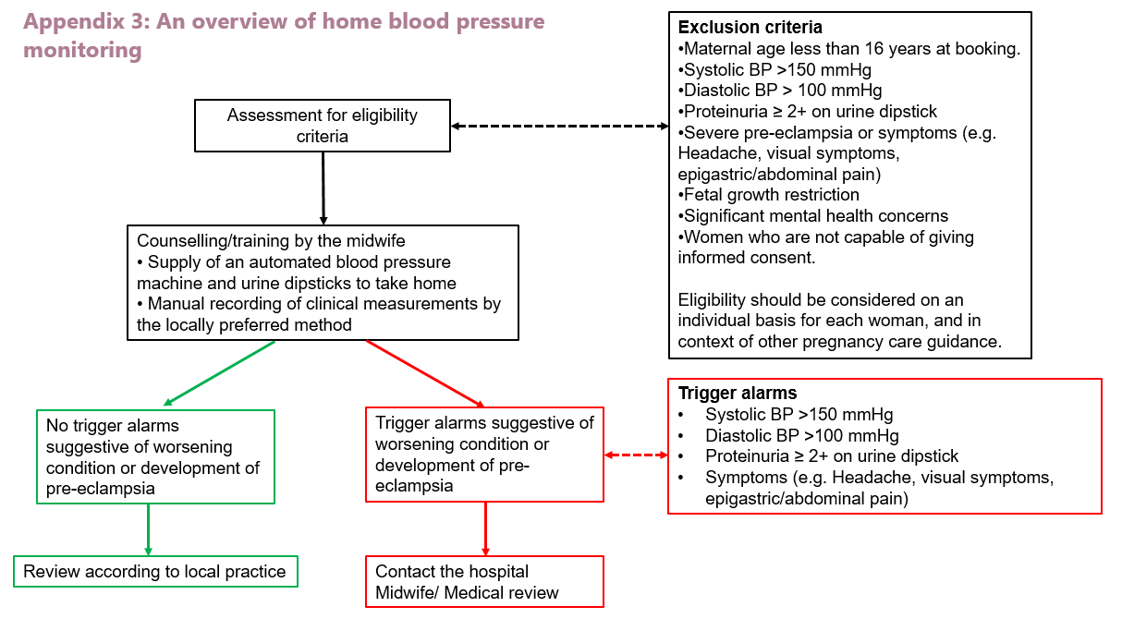

APPENDIX 4: How to Interpret Home Monitoring – Advice for Health Care Professionals

Condition | Results of home monitoring | Proposed Actions
New PIH or Ess HT without proteinuria (<1+ protein)  No symptoms | BP under control i.e.<140/90 | Consider:  Monthly review in Ess. HT without proteinuria (< 1+ protein)  1-2 weekly review in PIH with <1+ protein  USS for fetal growth as per hospital practice.
 | Systolic ≥ 140 and <150mmHg  and / or diastolic blood pressure ≥ 90 and <100mmHg  on 2 readings 5 mins apart | Recheck blood pressure in 30 mins and contact day assessment unit  Start or increase antihypertensive medication with repeat monitoring within 24-48 hours.
 | Systolic ≥150 mmHg/ Diastolic ≥100mmHg | Arrange for same day hospital assessment.  (aim for within 4 hrs)
New or pre-existing hypertension with proteinuria (≥1+ protein) after 20 weeks | Systolic ≥140mmHg and/or diastolic ≥90 mmHg and/or new proteinuria ≥1+ | Arrange immediate review at day assessment Unit
New proteinuria without hypertension after 20 weeks (gestational proteinuria) | ≥1+Protein | Repeat urinalysis in community in 1 week.  If ≥1+ proteinuria persists, send PCR / MSSU and review following week  If PCR negative<30mg/mmol continue with weekly assessment.  If PCR(>/=30mg/mmol) is raised, day assessment unit review within a week
 | 2+ Protein | Send PCR and refer for hospital assessment within 48 hours
Maternal Symptoms | Headache, epigastric pain and or visual disturbances without hypertension (systolic ≤140 mmHg and/or diastolic ≤90mmHg) with or without proteinuria | Depending on severity /nature of symptoms consider referral for same day hospital assessment OR reduce interval before next community antenatal assessment
 | Headache, epigastric pain and or visual disturbances with hypertension (systolic ≥140 mmHg and/or diastolic ≥90mmHg) or proteinuria (≥1+) | Immediate review at Day Assessment Unit

Resources accessed in orderto produce this guidance:
- https://www.rcog.org.uk/globalassets/documents/guidelines/2020-03-30-self-monitoring-of-blood-pressure-in-pregnancy.pdf
- https://www.health.org.uk/sites/default/files/16.%20St%20George's_HaMpton_v2.pdf

APPENDIX 5: GP letter /Primary MW

Useful contacts:
…………………– Day Assessment Unit Date:
………………… – Specialist Midwife

Dear Doctor,
Name:
Identifier number:
Address:

Re:

The above patient has been

Commenced Home Blood pressure monitoring during pregnancy with support from the day care unit. (OmronM4 Intellii - _______________Asset number essential for device safety) Device has been loaned to her for the duration of pregnancy and postnatal period.

Advised to take Aspirin at 150mg at night from 12 weeks until delivery/ ____ weeks gestation.
(Contra indications would include severe asthma, stomach ulcers or known allergy to aspirin)

Discharged from hospital follow-up on ______________________ medication. I would be grateful if you could review her in [insert number] weeks.

Kind regards

_______________________________________________________________(Name and Unit)
Appendix 6: Inclusion, Exclusion and Eligibility Criteria

Women with conditions described in Group 1 and Group 2 (a phased approach may be considered). This should not replace any appointments where the patient is receiving clinical review for her underlying medical condition (e.g. for respiratory review of cystic fibrosis or cardiac review of underlying cardiac condition) or where fetal assessment is required as part of the clinical review.
. Group 2
‘Increased risk’ of developing Pre-eclampsia
- Hypertensive disease during a previous pregnancy
- Chronic Kidney disease
- Autoimmune disease (eg SLE/ Antiphospholipid syndrome)

Group 1
‘Women identified as ‘high risk ‘of hypertensive complication including:
- Chronic Hypertension
- Current Gestational Hypertension (Pregnancy Induced Hypertension, PIH)
- Current Pre- eclampsia
Women who have been advised to shied because of serious underlying medical conditions:
- Cystic Fibrosis
- Solid organ transplant
- Cardiac conditions

Group 3
- Type 1/ Type 2 Diabetes
- Multiple pregnancy

Eligibility Criteria:

Eligibility should be considered on an individual basis for each woman, and in context of other pregnancy care guidance. Subject to availability of monitors and clinical judgement of her antenatal care team, this may include any woman.

The Royal College of Obstetrics & Gynaecology’s Guidance on self-monitoring in pregnancy suggests the following exclusion parameters:

Box 4: Exclusion criteria
•Maternal age less than 16 years at booking.
•Systolic BP >150 mmHg
•Diastolic BP > 100 mmHg
•Proteinuria ≥ 2+ on urine dipstick
•Abnormal blood count, liver and renal function blood tests as baseline and when new proteinuria present
•Severe pre-eclampsia
•Symptoms of headaches, visual symptoms, epigastric pain.
•Fetal growth restriction
•Significant mental health concerns may not be suitable.
•Women who are not capable of giving consent.

Appendix 7: Clinical Pathway

Suggested Follow up
Essential Hypertension: - virtual follow up monthly
Pregnancy Induced Hypertension: - weekly
Mild pre-eclampsia: - twice weekly; once face to face and once virtual

Appendix 8: Home Blood Pressure (BP) Monitoring in Pregnancy Study

Consent to contact form

The Scottish Government is supporting NHS boards across Scotland to implementation BP self-monitoring in pregnant women who are either shielded or at increased risk of complications of high blood pressure of pregnancy during the current COVID-19 pandemic. A small number of women will be invited to take part in a short telephone interview with a researcher to find out how they are getting on with home BP monitoring. This will help us to improve the service to women.

As you are being given a home BP monitor we would like you to consider agreeing to take part in an interview. You do not have to agree to take part and this will not affect your care. We are not asking you to decide now.

We are asking you to give permission for us to pass your contact details and some information about you, to a researcher from University of Stirling. They will keep your information confidential. They may then send you more information about the interviews and contact you by telephone or email to answer any questions and invite you to take part.

What will happen if I take part?
You will be contacted to arrange a convenient date and time for the interview, which will be a one-to-one conversation with a member of the research team by telephone. It is anticipated that your interview will last about 20 minutes, although this will depend on how much you have to say. The questions will all be about how you are getting on with your BP monitor. You can stop the interview at any time.

I give permission for the information below to be passed to the researcher at University of Stirling

I consent to be contacted about a possible telephone interview.

Name Gestation

Age Parity (number of pregnancies)

Address

Post code

Email: Telephone:

Signature: Staff Name

Date: Staff signature:

Please pass all consent to contact forms to the Lead Midwife for home BP monitoring in your maternity unit. University of Stirling will contact the Lead Midwife to arrange secure collection of the completed forms prior to commencing the research.

APPENDIX 9: Teach Back Questions (for use with women eligible for home blood pressure monitoring and urinalysis)

Teach back questions

(Please adapt to suit local processes and protocols)

Q Can you tell me what will alert you to take your BP readings?
A e.g. Florence on my phone

Q What position should you be in to take BP readings?
A Sitting, with arm resting in front, at heart level

Q Can you tell me the order in which you should record the numbers?
A Sys then Dias

Q What urine should you not test?
A First urine of the day

Q How long should you wait after dipping the stick in urine to read the result?
A 60 seconds

Q How should you record your urine result?
A PROT 0 / 1 / 2

Q Who should you contact if Florence says your reading is not normal?
A DBU or triage number

Document understanding e.g in Badger notes

Scan consent form and loan agreement form into notes

Amended from - HaMpton (Innovating for improvement –Elaine Sheehan and Professor Asma Khalid, St Georges Hospital, 2017)

